Microsoft Dynamics 365 Customer Engagement: Introduction to Customer Service
Module 02: Customers, Cases and Queues
Student Lab Manual

Conditions and Terms of Use
Microsoft Confidential
This training package is proprietary and confidential, and is intended only for uses described in the training materials. Content and software is provided to you under a Non-Disclosure Agreement and cannot be distributed. Copying or disclosing all or any portion of the content and/or software included in such packages is strictly prohibited.
The contents of this package are for informational and training purposes only and are provided "as is" without warranty of any kind, whether express or implied, including but not limited to the implied warranties of merchantability, fitness for a particular purpose, and non-infringement.
Training package content, including URLs and other Internet Web site references, is subject to change without notice. Because Microsoft must respond to changing market conditions, the content should not be interpreted to be a commitment on the part of Microsoft, and Microsoft cannot guarantee the accuracy of any information presented after the date of publication. Unless otherwise noted, the companies, organizations, products, domain names, e-mail addresses, logos, people, places, and events depicted herein are fictitious, and no association with any real company, organization, product, domain name, e-mail address, logo, person, place, or event is intended or should be inferred.

Copyright and Trademarks
© 2020 Microsoft Corporation. All rights reserved.
Microsoft may have patents, patent applications, trademarks, copyrights, or other intellectual property rights covering subject matter in this document. Except as expressly provided in written license agreement from Microsoft, the furnishing of this document does not give you any license to these patents, trademarks, copyrights, or other intellectual property.
Complying with all applicable copyright laws is the responsibility of the user. Without limiting the rights under copyright, no part of this document may be reproduced, stored in or introduced into a retrieval system, or transmitted in any form or by any means (electronic, mechanical, photocopying, recording, or otherwise), or for any purpose, without the express written permission of Microsoft Corporation.
For more information, see Use of Microsoft Copyrighted Content at
http://www.microsoft.com/en-us/legal/intellectualproperty/Permissions/default.aspx
DirectX, Hyper-V, Internet Explorer, Microsoft, Outlook, OneDrive, SQL Server, Windows, Microsoft Azure, Windows PowerShell, Windows Server, Windows Vista, and Zune are either registered trademarks or trademarks of Microsoft Corporation in the United States and/or other countries. Other Microsoft products mentioned herein may be either registered trademarks or trademarks of Microsoft Corporation in the United States and/or other countries. All other trademarks are property of their respective owners.

Contents
Exercise 1: Manage accounts and contacts 4
Task 1: Login to Dynamics 365 and create a sales account. 4
Task 2: Update an account record 4
Task 3: Deactivate a sales account 4
Task 4: Reactivate an account 4
Task 5: Add additional contacts 4
Exercise 2: Manage cases 4
Task 1: Login to Dynamics 365 and create a case. 4
Task 2: Create a Child Case 4
Task 3: Change case closure behavior 4
Task 4: Close child and parent cases 4
Exercise 3: Create a queue 4
Task 1: Create a new queue. 4

Exercise 1: Manage accounts and contacts

Objective
After completing this exercise, you will be able to create and update sales accounts in Dynamics 365.

Prerequisites
Access to the Dynamics 365 CE deployment

Scenario
You are signing into and starting to use the Dynamics 365 User Interface.

Task 1: Login to Dynamics 365 and create a sales account.
- Open your browser and type in the URL: https://<your organization>.crm.dynamics.com
- Sign in using the credentials assigned for your trial.
- After successfully signing in you will see the Dynamics 365 Landing page.
- Open the Customer Service Hub app.
- Select Accounts in the left navigation area of the window.
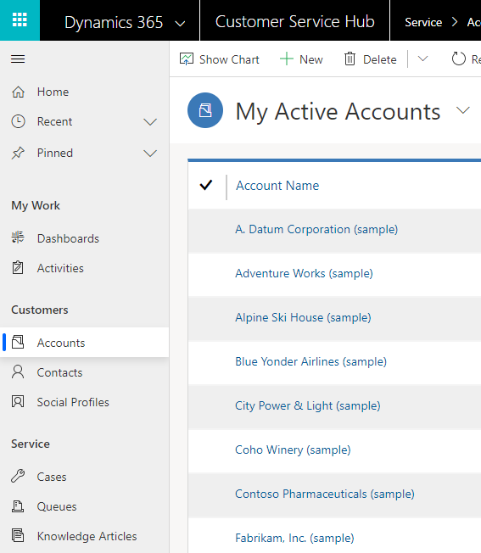
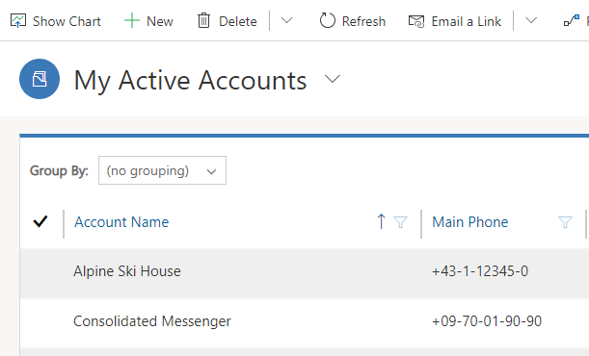
- You will see the My Active Accounts window. Select + New to create a new account.

- You will now see an empty account record. To create a new account, you need to provide at least an Account Name which is the only default required field for an account record. Next to Account Name enter Training Corporation.
- Select Save & Close.
- You can now return to the My Active Accounts page and see your newly created account.

Task 2: Update an account record
- Select Training Corporation in the list of accounts. Be sure not to select the phone number or primary contact column, as that will return that table’s information.
- You now see Training Corporation’s account page. Select the magnifying glass next to Primary Contact and then + New Contact.
- A Quick Create: Contact form appears. Enter the following information and Save:
First Name: John
Last Name: Smith
Job Title: Sales Manager
Email: john.smith@example.com
Business Phone: 224-123-0000
Street 1: 123 TC Way
City: Training City
Zip/Postal Code: 12345
- Select Save and Close.
- The Primary Contact field will be populated with John Smith now.
- Enter a Phone Number for the account: 224-123-0001. (This is below the account name on the form.)
- Scroll to the Address section. Enter the following information:
Street 1: 123 TC Way
City: Training City
State/Province: TX
Zip/Postal Code: 12345
Country/Region: USA
- Click the back arrow to get back to the My Active Accounts view.
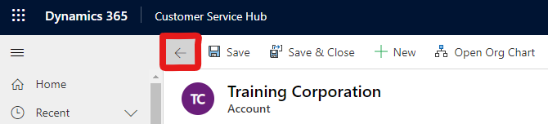

Task 3: Deactivate a sales account
- In the My Active Accounts view, mark the checkbox to the left of Training Corporation.
- Select Deactivate in the command bar. This deactivates the account and changes it to read-only mode.
- Select Deactivate in the Confirm Deactivation window.
- Training Corporation no longer shows in the My Active Accounts view.
- Choose the view selector next to My Active Accounts and then Inactive Accounts.
Training Corporation appears along with all other inactive accounts.

Task 4: Reactivate an account
- On the Inactive Accounts view, mark the checkbox to the left of Training Corporation.
- Choose Activate in the command bar.
- Select Activate from the pop-up box.
- Training Corporation will no longer appear on the Inactive Accounts page.
- Choose the view selector next to Inactive Accounts and select the My Active Accounts view.

Task 5: Add additional contacts
- In the My Active Accounts view, choose Training Corporation to open it.
- Under the Contacts sub-grid on the right, select + New Contact.
- Enter the following information for the new contact and then select Save and Close:
First Name: Jeff
Last Name: Training
Job Title: Sales Manager
Email: Jeff@example.com
Business Phone: 222-123-0002
- Repeat steps 2 and 3 to create another contact with the following information:
First Name: Jenny
Last Name: Training
Job Title: Regional Manager
Email: Jenny@example.com
Business Phone: 222-123-0003
There should now be 3 contacts for the Training Corporation account.

Exercise 2: Manage cases

Objective
After completing this exercise, you will be able to create new cases manually in the Customer Service Hub.

Prerequisites
Access to a Dynamics 365 CE deployment

Scenario
You need to create a new case for a customer that needs assistance with a product.

Task 1: Login to Dynamics 365 and create a case.
- Navigate to the Cases in the left area of the Customer Service Hub app window.
- Select + New Case in the command bar to create a new case.
- Enter Unable to access the website for the Case Title.
- Select Default Subject.
- Select Training Corporation for the Customer.
- Select Phone for the Origin
- Select the Details tab on the form.
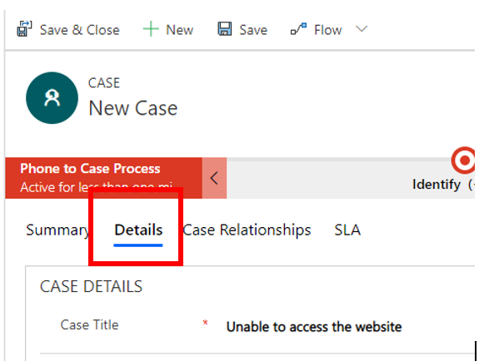
- Select John Smith for the Contact.
- Select Save from the command bar.

Task 2: Create a Child Case
- Select Create Child Case from the command bar. Notice that this opens the quick create form instead of the full form.
- Update the following columns:
Case Title: Unable to access the website child case
Subject: Default Subject
Case Type: Request
Contact: John Smith
Origin: Phone
- Select Save and Close.
- Select the Case Relationships tab and you can see the new child case that was created.

Task 3: Change case closure behavior
- Change the area in the Customer Service Hub by selecting Service in the lower left corner and then Service Management.
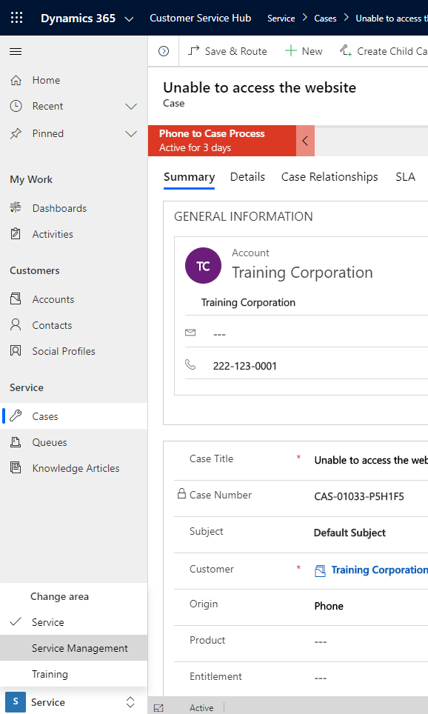

- Choose Parent Child Case Settings in the left navigation area.
- Select Don’t allow parent case closure until all child cases are closed for the Specify closure preference field.
- Select Save
- Change the area back to Service by selecting Service Management in the lower left and choosing Service.
- Select Cases in the left navigation area.
- Open the Unable to access the website case created previously.
- Choose Resolve Case in the command bar.
- Enter Access granted in the Resolution field.
- Select 15 minutes for the Billable Time.
- Choose Resolve
- You should receive an error that the active child case should be closed before closing the parent.
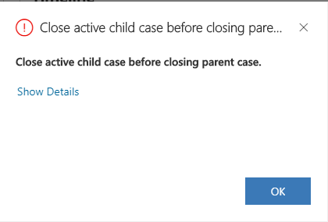
- Click OK for the error message.

Task 4: Close child and parent cases
- Select the Case Relationships tab.
- In the Child Cases sub-grid, choose the child case to open it.
- Select Resolve Case from the command bar.
- Enter Access granted for the Resolution field.
- Select 15 minutes for Billable Time.
- Select Resolve
- Then select the Details tab.
- Pick the Unable to access the website link Parent Case field in the middle section of the form.
- Next choose Resolve Case from the command bar.
- Enter Access granted for the Resolution field.
- Select 15 minutes for the Billable Time.
- Choose Resolve. The parent case is now closed because we closed the child case first.

Exercise 3: Create a queue

Objective
After completing this exercise, you will be able to create a queue manually.

Prerequisites
Access to a Dynamics 365 CE deployment.

Scenario
You need to be able to add cases to a queue for customer service representatives to be able to pull the cases as they are available.

Task 1: Create a new queue.
- In the Customer Service Hub app, select Service in the lower left corner to change the area and choose Service Management.
- Select Queues in the left navigation area.
- Select New from the command bar.
- Enter Support Queue for Name.
- Leave the Type as Public.
- We have not setup email for the test environment so enter a dummy email address in the Incoming Email field. (ex. support@<yourorgname>.onmicrosoft.com)
- Leave the default of All email messages in the Convert Incoming Email to Activities field.
- Click Save
- Notice it has now created a Mailbox record for the queue.
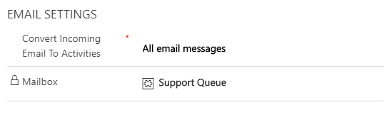
- Create a second queue called Priority Support by repeating steps 3-9.

