Microsoft Dynamics 365 Customer Engagement: Introduction to Customer Service
Module 03: Service Terms
Student Lab Manual

Conditions and Terms of Use
Microsoft Confidential
This training package is proprietary and confidential, and is intended only for uses described in the training materials. Content and software is provided to you under a Non-Disclosure Agreement and cannot be distributed. Copying or disclosing all or any portion of the content and/or software included in such packages is strictly prohibited.
The contents of this package are for informational and training purposes only and are provided "as is" without warranty of any kind, whether express or implied, including but not limited to the implied warranties of merchantability, fitness for a particular purpose, and non-infringement.
Training package content, including URLs and other Internet Web site references, is subject to change without notice. Because Microsoft must respond to changing market conditions, the content should not be interpreted to be a commitment on the part of Microsoft, and Microsoft cannot guarantee the accuracy of any information presented after the date of publication. Unless otherwise noted, the companies, organizations, products, domain names, e-mail addresses, logos, people, places, and events depicted herein are fictitious, and no association with any real company, organization, product, domain name, e-mail address, logo, person, place, or event is intended or should be inferred.

Copyright and Trademarks
© 2020 Microsoft Corporation. All rights reserved.
Microsoft may have patents, patent applications, trademarks, copyrights, or other intellectual property rights covering subject matter in this document. Except as expressly provided in written license agreement from Microsoft, the furnishing of this document does not give you any license to these patents, trademarks, copyrights, or other intellectual property.
Complying with all applicable copyright laws is the responsibility of the user. Without limiting the rights under copyright, no part of this document may be reproduced, stored in or introduced into a retrieval system, or transmitted in any form or by any means (electronic, mechanical, photocopying, recording, or otherwise), or for any purpose, without the express written permission of Microsoft Corporation.
For more information, see Use of Microsoft Copyrighted Content at
http://www.microsoft.com/en-us/legal/intellectualproperty/Permissions/default.aspx
DirectX, Hyper-V, Internet Explorer, Microsoft, Outlook, OneDrive, SQL Server, Windows, Microsoft Azure, Windows PowerShell, Windows Server, Windows Vista, and Zune are either registered trademarks or trademarks of Microsoft Corporation in the United States and/or other countries. Other Microsoft products mentioned herein may be either registered trademarks or trademarks of Microsoft Corporation in the United States and/or other countries. All other trademarks are property of their respective owners.

Contents
Lab 1: Entitlements in Dynamics 365 6
Exercise 1: Create an entitlement template 7
Task 1: Create an entitlement template that supports 25 cases. 7
Task 2: Add entitlement channels to limit the type of interactions. 7
Exercise 2: Create a new entitlement for a customer 9
Task 1: Create a new entitlement 9
Task 2: Create a new case that uses an entitlement 10
Lab 2: Service Level Agreements in Dynamics 365 11
Exercise 1: Create holiday and customer service schedule 12
Task 1: Create a holiday schedule. 12
Task 2: Create a customer service schedule. 13
Exercise 2: Create a service level agreement 15
Task 1: Create a SLA KPI. 15
Task 2: Create service level agreement details. 15
Task 3: Create SLA Items. 15
Task 4: Associate the SLA to an entitlement. 16
Task 5: Update SLA settings to allow manual override 17
Task 6: Test the new SLA 17

Lab 1: Entitlements in Dynamics 365

Introduction
In this lab, you will learn how to configure and manage entitlements.

Exercise 1: Create an entitlement template

Objective
After completing this exercise, you will be able to create a template to use when setting up entitlements for customers.

Prerequisites
Access to the Dynamics 365 CE deployment

Scenario
You are just starting to use customer service and need to have a template for creating entitlements to make setup easier when a new contract is entered.

Task 1: Create an entitlement template that supports 25 cases.
- Open the Customer Service Hub app.
- Navigate to the Service Management area.
- Select Entitlement Templates in the left navigation area under the Templates group.
- Choose +New.
- Enter the following information for the new template:
Entitlement Template Name: Standard Support
Restrict based on entitlement terms: Yes
Allocation Type: Number of cases
Decrease Remaining On: Case Creation
Total Terms: 25
- Select Save in the command bar.

Task 2: Add entitlement channels to limit the type of interactions.
- In the Entitlement Channels sub-grid, click the ellipses and select +New Entitlement Template Channel.
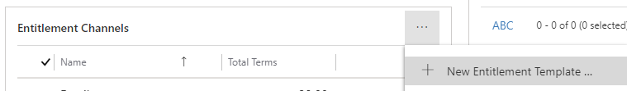
- Select Phone for the Name.
- Enter 5 for the Total Terms.
- Select Save & Close.
- Click the ellipses in the Entitlement Channels sub-grid again and select +New Entitlement Template Channel.
Select Email for the Name.
Enter 20 for the Total Terms.
- Select Save & Close in the command bar. You should now see there are 2 channels available for this template.
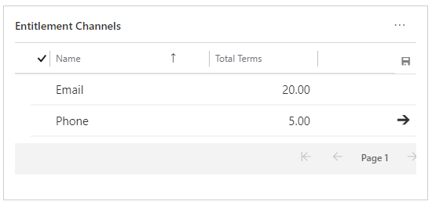

Exercise 2: Create a new entitlement for a customer

Objective
After completing this exercise, you will be able to create new entitlement for a customer.

Prerequisites
Access to a Dynamics 365 CE deployment and completion of exercise 1 to create an entitlement template

Scenario
You need to create a new entitlement for Fabrikam, Inc. so they can open support cases.

Task 1: Create a new entitlement
- In the Service Management area in the Customer Service Hub app, select Entitlements in the left navigation area under the Service Terms group.
- Select the drop-down next to + New in the command bar and choose From Template.
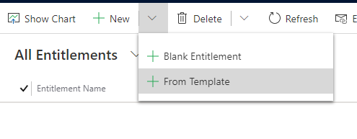
- Select the Standard Support template created previously and then Select.
- Enter the following information:
Name: Fabrikam Standard Support
Primary Customer: Fabrikam, Inc.
Start Date: choose the first day of the current month
End Date: choose the date a year out from the start date
- Select Save in the command bar. Notice how the entitlement channels have been automatically added from the template during the save.
- Select Activate in the command bar.
- When prompted, choose Activate to confirm activation.
- Choose Set as Default in the command bar so this entitlement defaults when new cases are created.
- When prompted, confirm that you want to set this as the default.

Task 2: Create a new case that uses an entitlement
- In the Customer Service Hub app, change the area to Service.
- Select Cases in the left navigation area.
- Choose +New Case.
- Enter the following information:
Case Title: Training Case
Subject: Default Subject
Customer: Fabrikam, Inc.
Origin: Phone
- Select Save. Notice that the Entitlement field is populated automatically. Also, notice that in the Entitlements sub-grid that Remaining Terms is now set to 24.
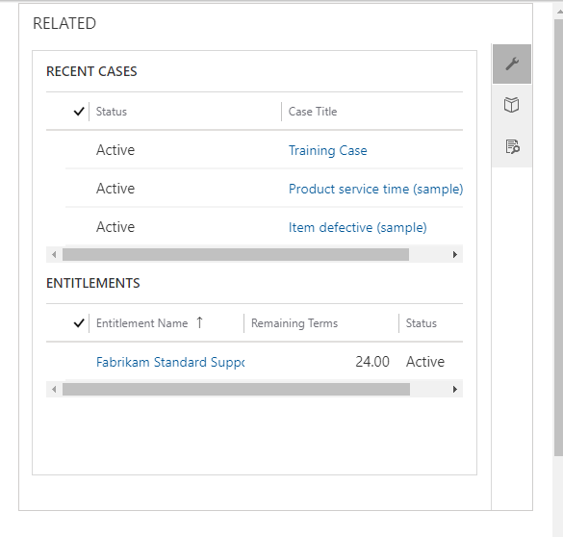
- Choose the Details tab.
- Select Eva Corets as the contact.

Lab 2: Service Level Agreements in Dynamics 365

Introduction
In this lab, you will learn how to configure and manage service level agreements.

Exercise 1: Create holiday and customer service schedule

Objective
After completing this exercise, you will be able to create a holiday and customer service schedule that ensure a service level agreement is not negatively impacted by business closures.

Prerequisites
Access to the Dynamics 365 CE deployment.

Scenario
You are preparing to setup a standard service level agreement (SLA) to be used with new entitlements. You need to configure the business closures and hours of operation, so the SLA is not negatively impacted when the business is closed.

Task 1: Create a holiday schedule.
- Open the Customer Service Hub app.
- Navigate to the Service Management area.
- Choose Holiday Schedule from the left navigation area.
- Select +New
- Enter US Holidays for the Name.
- Select Create
- On the Holidays sub-grid select + New.
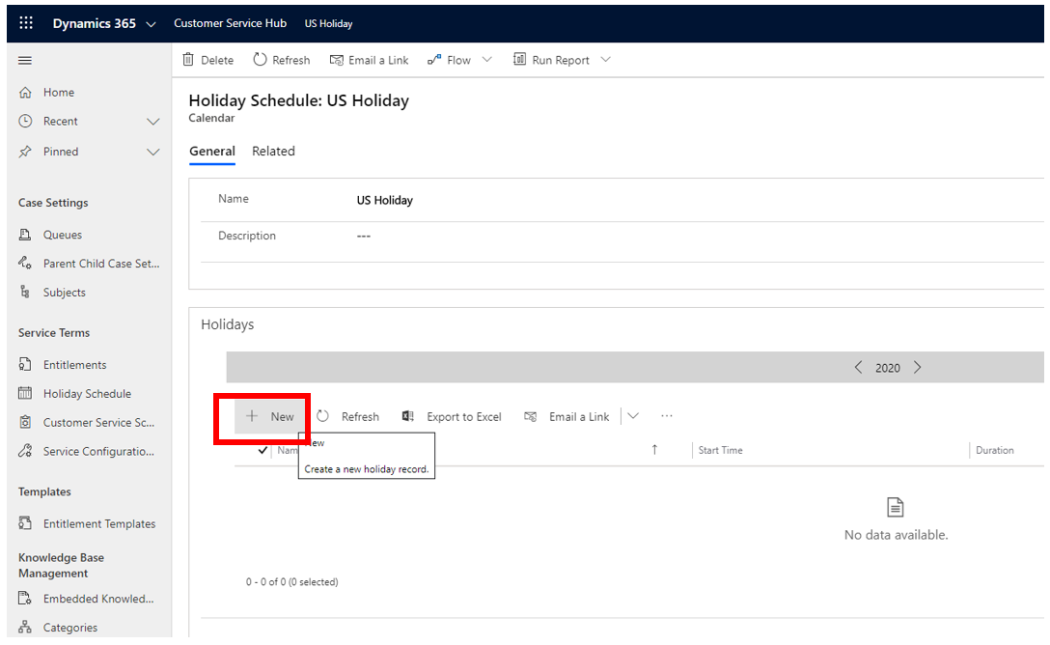
- Enter the following information:
Name: Labor Day
Start Date: 9/5/2022
End Date: 9/5/2022
- Select OK
- On the Holidays sub-grid choose + New again.
- Enter the following information:
Name: Christmas
Start Date: 12/24/2022
End Date: 12/25/2022
Notice how this holiday can span multiple days.
- Click OK
- Repeat step 10 and enter any additional holidays you choose.

Task 2: Create a customer service schedule.
- Select Customer Service Schedule in the left navigation area.
- Choose + New
- Enter US Business Hours in the Name.
- Select Create
- Uncheck the Sunday and Saturday checkboxes.
- Change the Holiday Schedule drop-down to Observe.
- Select the US Holiday schedule you just created in the lookup for the calendar.
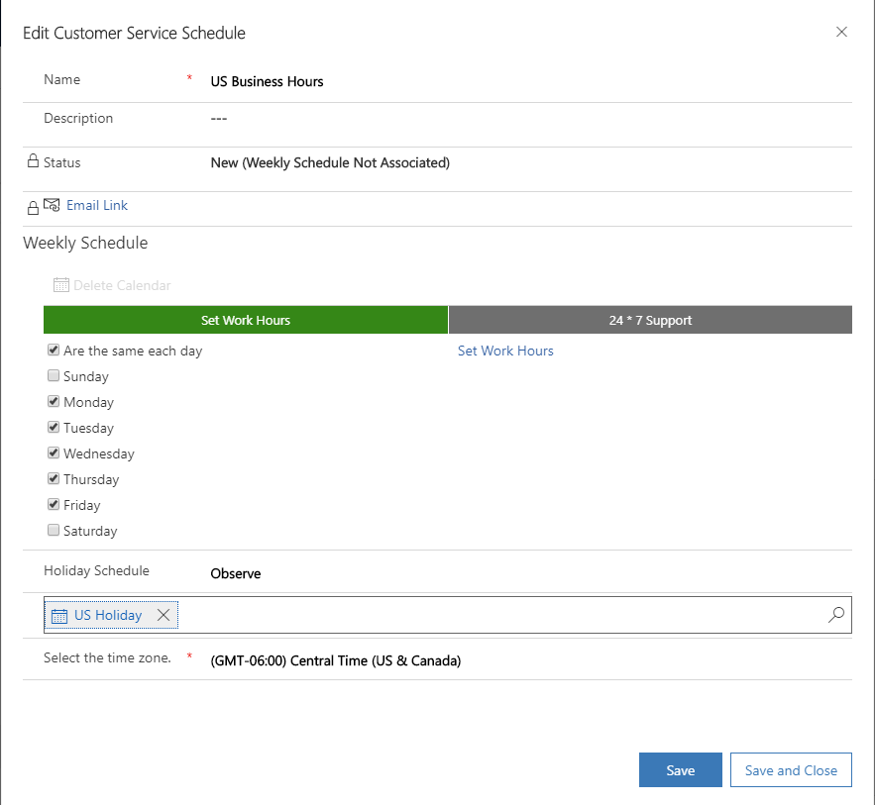
- Select the blue Set Work Hours link to the right of the Are the same each day checkbox.
- Leave the Start as 8:00 AM and change the End to 8:00 PM.
- Select OK
- Save and Close.

Exercise 2: Create a service level agreement

Objective
After completing this exercise, you will be able to create key performance indicators to determine if your business has successfully attained the agreed upon service level.

Prerequisites
Access to the Dynamics 365 CE deployment.

Scenario
You have configured your company holiday and customer service schedule and need to use those to complete the configuration of your standard service level agreement.

Task 1: Create a SLA KPI.
- Open the Customer Service Hub app.
- Navigate to the Service Management area.
- Select SLA KPIs.
- Choose +New
- Enter/Select the following information:
Name: First Response By
Entity Name: Case
KPI Field: First Response By KPI
Applicable From: Created On
- Select Save
- Select Activate in the command bar and select Activate again in the pop-up to confirm activation.

Task 2: Create service level agreement details.
- Select Service Level Agreements under the Service Management Area.
- Choose +New.
- Enter Standard SLA for the Name and select Case under the Primary Entity field.
- Save

Task 3: Create SLA Items.
- Select + New SLA Item in the SLA Items sub-grid.
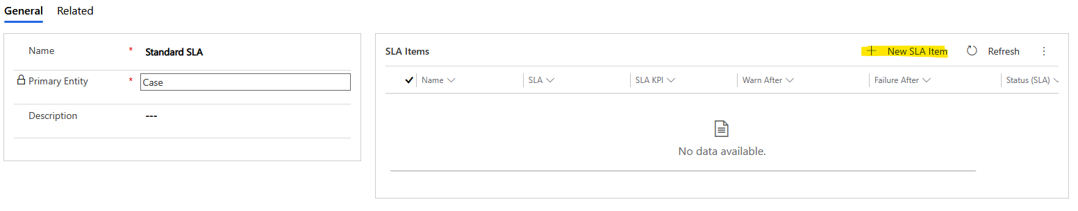
- Enter High Priority for the Name.
- Select First Response By in the KPI field
- Select US Business Hours in the Business Hours field
- In the Applicable When section, click + Add then Add row and enter the condition as shown below:
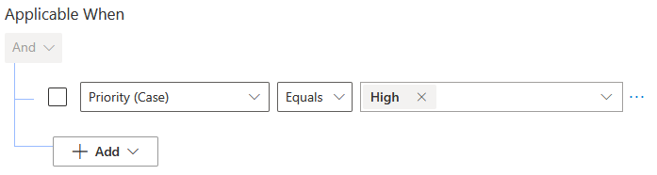
- In the Success Conditions section, click + Add then Add row and enter the condition as shown below:
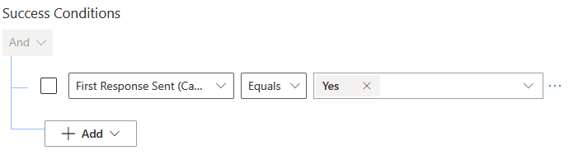
- Change Failure After to 2 hours and the Warn After to 1.5 hours.
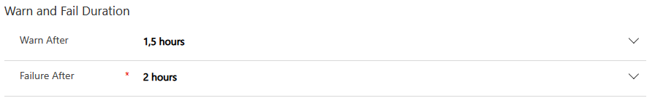
- Save & Close.
- Select + New SLA Item in the SLA Items sub-grid again.
- Enter Regular Priority for the Name.
- Select First Response By in the KPI field
- Select US Business Hours in the Business Hours field
- In the Applicable When section, click + Add then Add row and enter the condition as shown below:
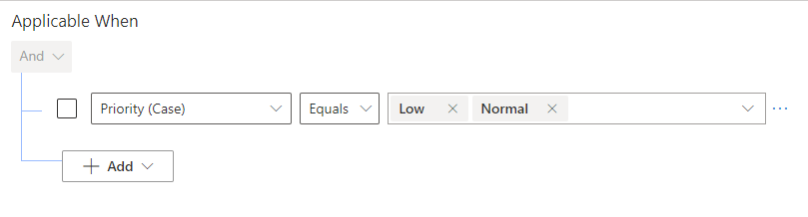
- In the Success Conditions section, click + Add then Add row and enter the condition as shown below:
- Change Failure After to 8 hours and the Warn After to 7.5 hours.
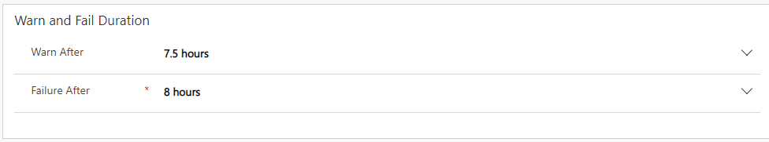
- Save & Close.
- Select Activate in the command bar and select Activate again in the pop-up to confirm activation.

Task 4: Associate the SLA to an entitlement.
- In the Service Management area, select Entitlements in the left navigation pane.
- Choose the Fabrikam Standard Support entitlement created earlier to open it.
- Select Deactivate in the command bar and click Deactivate again when prompted to confirm the deactivation.
- Select Standard SLA for the SLA field.
- Select Activate in the command bar and select it Activate again in the pop-up to confirm the activation.

Task 5: Update SLA settings to allow manual override
- Select Service Configuration Settings in the left navigation area.
- Change the Apply SLA after manual override to Yes.
- Save

Task 6: Test the new SLA
- Change the area in the Customer Service Hub app to the Service area.
- Select Cases in the left navigation area.
- Choose + New Case.
- Enter the following information for the new case:
Case Title: Need assistance with an error.
Customer: Fabrikam, Inc.
Origin: Phone.
Entitlement: Fabrikam Standard Support.
- Select Save
- Notice a timer now shows under the account information and above the case title. The SLA was applied automatically because it is associated to the entitlement.
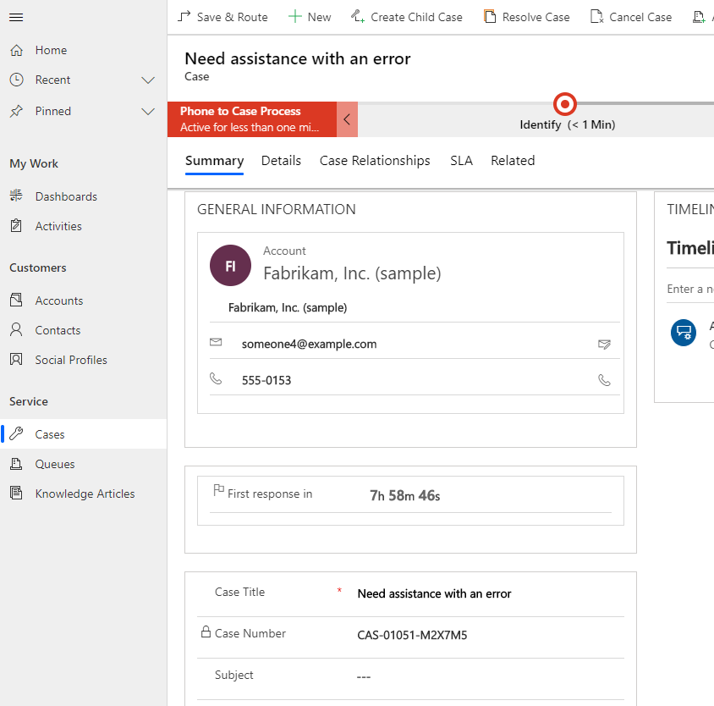
- Click on the dropdown next to the owner of the record in the header.
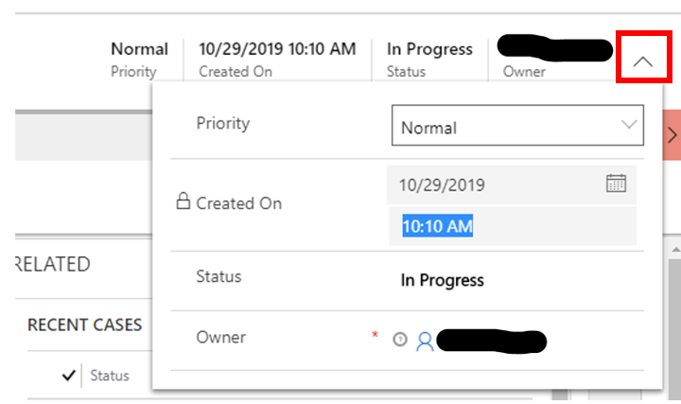
- Change the Priority field to High.
- Wait for the record to automatically save or select Save in the command bar. Notice that the timer has been updated.


