ALM Accelerator for Power Platform Setup (manual setup)
Steps to manually setup the accelerator are here

These are some notes as you go through the setup:
- Ensure prerequisites are completed - Set up ALM accelerator for Microsoft Power Platform components manually - Power Platform | Microsoft Docs
- Complete the foundational setup and continue to the end of the documentation - Set up ALM accelerator for Microsoft Power Platform components manually - Power Platform | Microsoft Docs
- When you get to the step to clone the repository (clone repository reference), when you go to the URL, choose Code and then select the URL for the Clone and not the URL of the page you are directed to or it will fail:
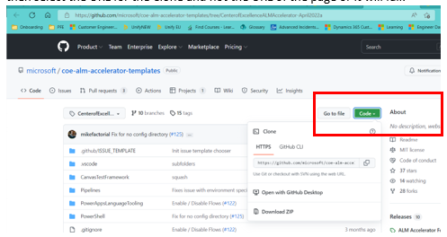
- When you get to point of installing the accelerator (installing solution reference ) it will ask you for connections. For the HTTP with Azure AD you will enter:
https://graph.microsoft.com
Put it in both fields:
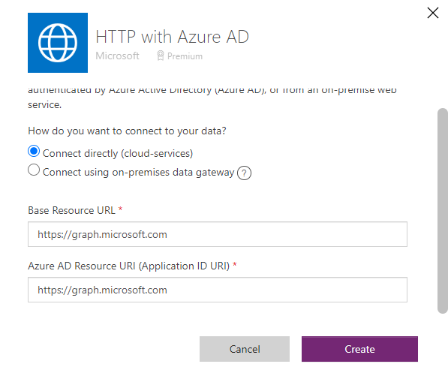

- When you get to the configuring the DevOps custom connector (DevOps custom connector reference) you may run into an error getting organizations (203). You may need to delete the connection that shows in the Test window and create a new one.
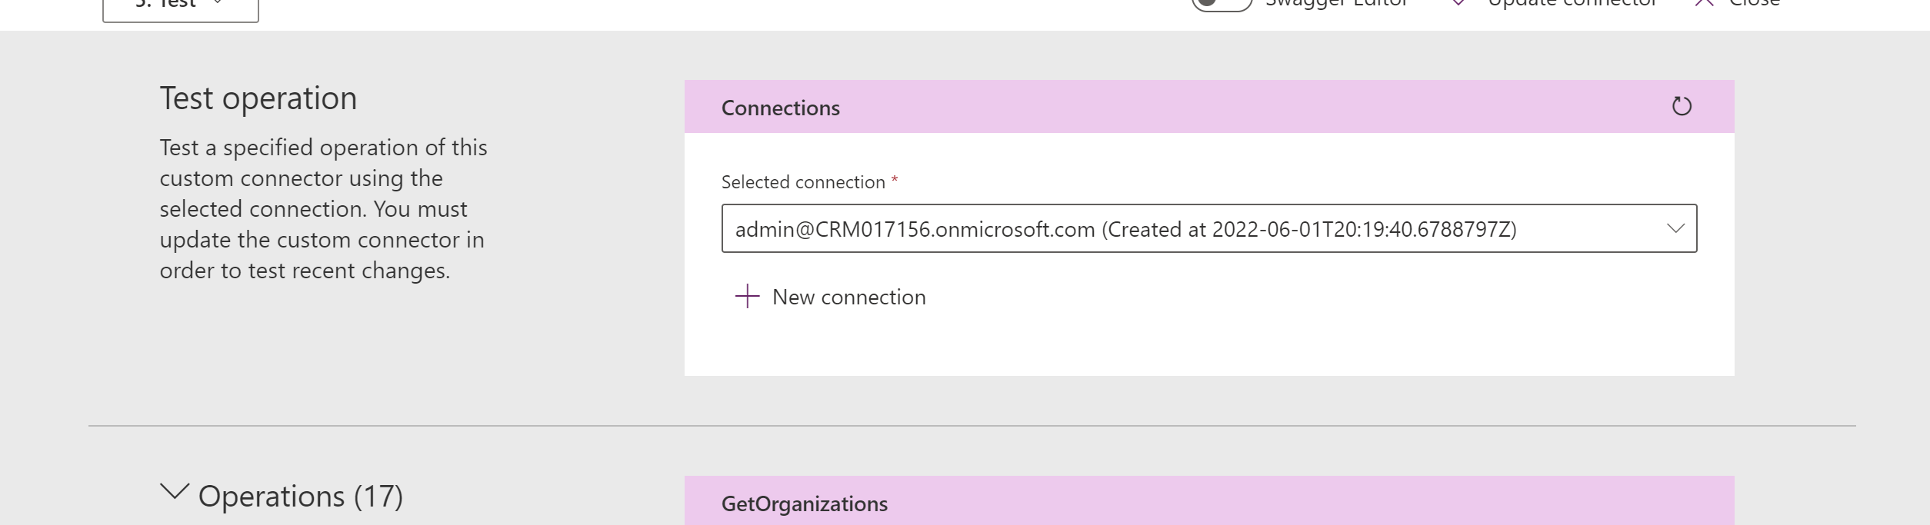
If this does not resolve it, go to this issue for resolution steps - [ALM Accelerator - BUG]: Custom Connector, GetOrganizations unable to resolve · Issue #2202 · microsoft/coe-starter-kit · GitHub
- Configure user permissions - Configuring the ALM Accelerator for Power Platform app user permissions - Power Platform | Microsoft Docs
- Configure deployment user settings and profiles - Configuring the ALM Accelerator for Power Platform deployment user settings and profiles - Power Platform | Microsoft Docs
- Advanced Maker experience - ALM Accelerator for Power Platform advanced maker experience - Power Platform | Microsoft Docs The first time you commit a solution, select the option to create a new branch. When you deploy, you select the branch you created in DevOps in the previous steps for the destination.
- Your pipeline may run into errors due to a change in the free tier for Azure Pipelines.
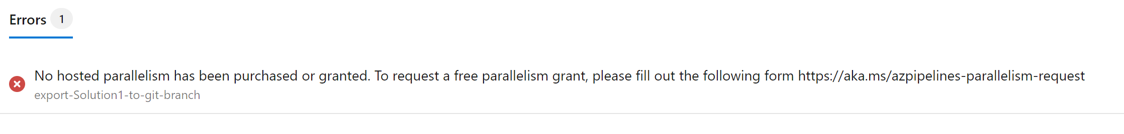There is a link to a form to complete if you run into this issue if you are using a trial. Change in Azure Pipelines Grant for Private Projects - Azure DevOps Blog (microsoft.com). Please note it takes 2-3 business days to get a response.

